Module 7 Assignment
Given ERD
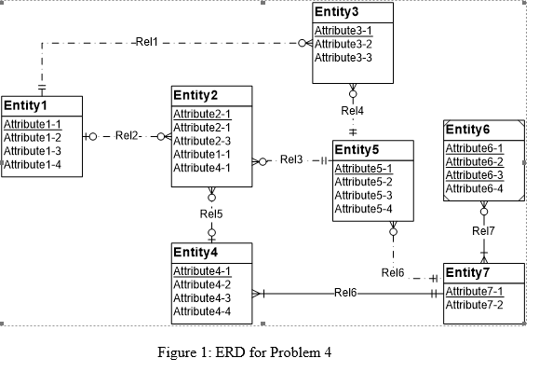
Above ERD Diagram has following errors:
- Redundant FK(Foreign Key) Rule Violation-At Rel2, Entity 2 is having Attribute1-1 which is primary key of Entity 1.
- Redundant FK(Foreign Key) Rule Violation-At Rel5, Entity 2 is having Attribute4-1 which is primary key of Entity 4.
- Attribute Name Rule Violation-Entity 2 is having 2 attributes with same name Attribute2-1.
- Identification Dependency Cardinality Rule Violation (At Rel7). Cardinality of Weak Entity should be (1,1)
- Identifying Relationship Rule Violation. The relationship between Entity4 and Entity7 is given identifying but none of them is weak entity.

ERD after resolving the errors

